# Block Diagram

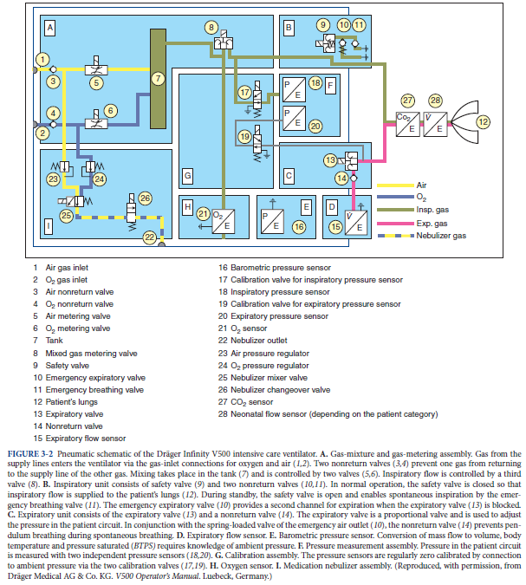

P.67 (Martin)

# Power Input

INPUT: 110/240VAC @ 50/60Hz,

Battery: 10 – 30VDC

Outlet Pressure (o2/Air): 50psi

Internal Pressure regulator: ~20psi

# Air Conditioning:

Warmed air

Humidified Air

# Mechanism:

Air Compressor or Air blower

# Design Spec

## Battery

The battery requirements are as follows:

12V, at least, 60Ah , lead-acid for reduced cost. This would mean that the system is capable of running at least for 190 mins at full load (worst case scenario).

The battery is connected to the circuit via a screw terminal. The circuit is protected from accidental reverse polarity connection of the battery as well as battery transients due to load variation.

## Power Supply

A three terminal IEC complaint medical grade power entry receptable is used to power the system in case the battery is not used or can be used to charge the battery and power the system if the battery is hooked up the system.

The device can accept voltage inputs ranging from 85VAC to 250VAC and thus can be used around the globe without concern to the outlet voltage.

The system is also fused incase of failure both due to internal and/or external factors. Once the wall power enters the system the whole unit is powered using an Isolated 12V. This means that all users and patients are completely isolated from the mains power supply aacccording ISO 80601.

# Processor

There are multiple sensors (instrumentation) and transducers being monitored and regulated as such a high performance MCU was chosen , in this case STM32F40LVCT6. The MCU will be responsible for :

* Assisting, monitoring and controlling of ventilation
* Control air mixture percentage
* A Human interface beduim to allow the opreator to monitor and control main parameters such as repiratino pressure provide feedback to the users such as control mode and measured snensor data
* Use PID control system algorithm to function 4 valves

The reason this processor was chosen was due to the following:

* High efficency with low voltage (3.3V)
* 32-bit ARM cortex –M4
* 246KB flash memory/512bytes OTP memory /64KB SRAM
* BOR monitoring
* 16 channel ADC (12-bit)
* 11 timers
* 3x I2C interfances
* Accurate measurements and fast control

# Alarm system

Using measured patient data such as exhaled volume and airway pressure, the ventilation system will be able to detect whether a breath has been taken. If the controller detects that no inhalation takes place within a certain period of time the controller will sound a buzzer at 4KHz and 90dB. There are different beeping sequence for different conditions which will be controlled by the MCU.

Also a bright red LED will be flashing to indicate a fault condition.

## Actuators

There are 4 electromechanical valves that are used as following:

* Control O2 input
* Control Air compressor input
* Manage Inhaled air pressure
* Manage Exhaled air pressure

. Each of those valves operate at 5V. Due to the large inductances associated with switching the valves the 5V is galvanically isolated from the MCU and is controlled using optocouplers.

## Pressure Sensors

There are 4 pressure sensors that are used as analog sensor inputs to the MCU to regulate air flow, namey:

1. 1x Lung Pressure Sensor- It is used to calculated the volume of air in the lungs via the pneumotachometer tubing
2. 1x Tank Pressure Sensor- It is used to determine the air to oxygen mixture ratio
3. 2x Differential Pressure Sensor (Flow sensor) used to determine the volume of air inhaled and volume of air exhaled respectively